Modern Slavery Act Transparency Statement for Tangent International Limited

OPENING STATEMENT FROM SENIOR MANAGEMENT
Tangent International is dedicated to preventing modern slavery and human trafficking from taking place within its business and supply chain and we place the same expectation on our suppliers.
Tangent is committed to carrying out its business to the highest ethical standards and by way of public statement to that effect has signed up to the United Nations Global Compact, which among the 10 Core Principles that signatories embrace and demonstrate are those covering fundamental Human and Labour Rights:-

Human Rights
Principle 1: Businesses should support and respect the protection of internationally proclaimed human rights; and
Principle 2: make sure that they are not complicit in human rights abuses.
Labour
Principle 3: Businesses should uphold the freedom of association and the effective recognition of the right to collective bargaining;
Principle 4: the elimination of all forms of forced and compulsory labour;
Principle 5: the effective abolition of child labour; and
Principle 6: the elimination of discrimination in respect of employment and occupation.

STRUCTURE AND SUPPLY CHAINS
The Company is engaged on an International basis providing services to the global Manufacturing; Engineering and Telecommunications Sectors. It is the largest operating company under the Holding Company - Tangent International Group Plc with 64 staff who predominantly work out of the Head Office premises in Billericay, Essex, U.K. Services range across temporary and permanent staffing solutions to a client-base of over 600 entities world-wide. The following weblink provides more information regarding the nature of our business https://www.tanint.com/.
The type of business requires that we work in conjunction with a range of suppliers providing office utilities; office supplies and consumables, and information services to our Head Office and to our overseas offices. In addition we utilise the services of a number of selected suppliers in countries world-wide providing activities such as local payments; local employment registration; work permit and visa solutions; background checking, and a number of other services to ensure that the overall services we provide are delivered compliantly at the local level to our clients. We have provided services in over 190 countries.
Searching for the correct resource to fill the temporary and permanent roles that our clients forward to us is undertaken against a) the considerable database of qualified engineers that Tangent has developed in the 30+ years it has been in business, b) through social media sources, c) through the Tangent website, or through d) other advertising formats. In addition we provide payroll services for a range of consultants introduced to us by our clients.
Our clients are almost without exception multi-national companies that themselves operate very much in the media spotlight and within the tight legal and moral frameworks of the countries where they are domiciled and operate. These clients operate active and wide reaching Corporate & Social Responsibility infrastructures and expect their suppliers to do the same

POLICIES RELATING TO SLAVERY AND HUMAN TRAFFICKING
The following policies exist within our organisation which demonstrate the seriousness we place on ethical trading and on our opposition to modern slavery:
- Fair Business Practice Policy:-
- United Nations Global Compact signatory:-

- Modern Slavery, Child Labour and Human Trafficking:-
Modern slavery is a term widely used to encompass slavery, servitude (in its many guises), forced and compulsory labour, bonded and child labour and human trafficking.
Human trafficking is where a person(s) arranges or facilitates the travel of another person with a view to that person being exploited.

Commitments
- We have zero tolerance of Modern Slavery in our company, group and supply chain – it is a crime under the Modern Slavery Act, 2015, a violation of fundamental human rights running counter to the objectives of the U.N. Global Compact that we have signed up to.
- The prevention, detection and reporting of modern slavery in any part of the activities of our organisation, and our supply chain, is the responsibility of all those working for us or on our behalf. Engaging in, facilitating, or not reporting suspicions that Modern Slavery may be happening, therefore breaching this policy may lead to disciplinary proceedings being taken against the individual.
- Tangent is committed to engage with all stakeholders and suppliers to address the risk of modern slavery happening in our operations and supply chain.
- We take a risk-based approach to our contracting processes and keep them under review. We assess whether the circumstances of the business we are undertaking merit the inclusion of specific prohibitions against the use of modern slavery and trafficked labour in our contracts with third parties. Using our risk-based approach we will also assess the efficacy of writing to suppliers requiring them to comply with our Policies, or to at least publish their own equivalent documents that attain comparable aims.
- As part of our on-going risk assessment and due diligence processes we will consider whether the circumstances of our relationship with suppliers warrants us carrying out audits of suppliers to ensure they adhere to the requirements of our policies.
- If in the course of our engagement with other individuals or organisations working within our supply chain we learn of them breaching our policies we will ensure that we take appropriate action – ranging from termination of relationship to other forms of remediation depending upon the nature of the breach and the impact upon those affected by the breach.
Public Interest Disclosure / Whistle-blowing Policy:-

DUE DILIGENCE PROCESSES RELATING TO SLAVERY AND HUMAN TRAFFICKING
As part of our efforts to monitor, manage and reduce the risk of slavery and human trafficking occurring within our business or supply chains, we adopt the following due diligence procedures:

- New clients – on-boarding new clients is undertaken under the umbrella of our Fair Business Practice Policy
:-
- New Suppliers - on-boarding new suppliers is undertaken under the umbrella of our Sustainable Procurement Policy:-

- New Consultants:- on-boarding new consultants is in response to specific advertised job roles. Nearly all the job positions we look to fill involve senior and/or well paid consultants typically outside of the parameters of employment associated with modern slavery. We deal with individuals and all contract related documentation is specific to that person and not dealt with by third parties.

Our processes aim to:
- Ensure that we carry on business to the highest possible Internationally Recognised Ethical Standards.
- Ensure that the companies we select to use within our Supply Chain operate to the same ethical standards we recognise or at the very least operate within a legal framework that lays down a proper skeleton for ethical behaviour.
- Ensure that the companies we undertake business with operate to internationally recognised ethical standards concomitant with the territory.
- Identify, monitor and manage areas of potential risk in our business and supply chains
- Scrutinise any identified areas of risk within our business and supply chains
- Adopt a zero tolerance approach to slavery and human trafficking throughout the organisation and our supply chains
- Provide support and protection from detriment or disadvantage to any person who, in the public interest, raises genuine concerns amounting to a protected disclosure.
- Through appropriate training – ensure all employees are aware of the risks of modern slavery and human trafficking in our business and supply chains.

RISK AND COMPLIANCE
Our organisation regularly evaluates the nature and extent to which our business and our supply chains are exposed to a number of business and associated risks – of which the risk of modern slavery occurring is one element.
In general - We do not consider that we operate in high risk sectors (90%+ of the roles we fill are for qualified consultants, often in to senior roles, within the IT, Telecoms, Manufacturing and Engineering industries.
That said we are far from complacent and regularly reassess the potential for modern slavery and human trafficking at various points of the recruitment processes. If we identify a potential risk we prioritise the level of risk identified and take appropriate action to put remedial measures in place. Such measures depend on the severity level of the risk identified but may include improved internal purchasing practices or industry collaboration.
SUCCESS AND EFFECTIVENESS OF OUR PROCESSES
For a company of the size and footprint of Tangent we are proud of the fact that our Corporate & Social Responsibility infrastructure, of which our Modern Slavery & Human Trafficking Policy is one important element, punch above their weight. Tangent has for a long time placed great import upon CSR but in November 2015 first signed up to the on-line CSR evaluation portal Ecovadis to obtain an external scoring and benchmarking of the overall Tangent CSR structure. That first assessment gave the Tangent Group a Silver Award for what we had in place then – placing us within the top 18% of recruitment companies assessed by Ecovadis.

November 2017 saw a reassessment by Ecovadis of the dynamic Tangent Group CSR profile with the following scoring:-
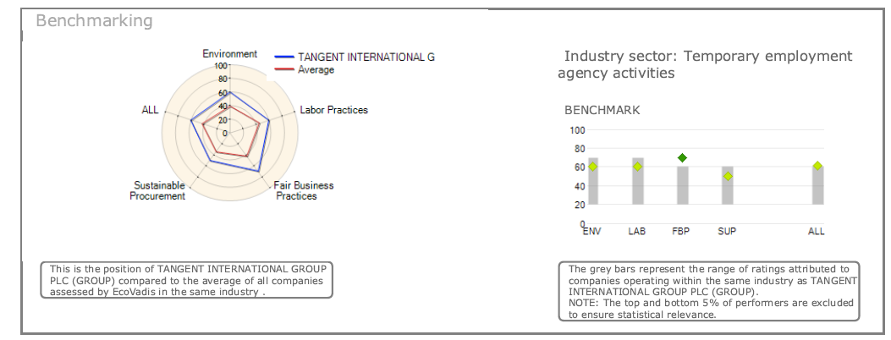

Tangent has now been placed within the top 7% of all Employment Agencies, and top 6% of all Suppliers assessed by Ecovadis – with an industry-leading scoring particularly for Fair Business Practices. We strive to drive these scores higher still as tangible commitment to pursuing high ethical business standards.

Signature:
Simon Dear – Chief Executive Officer
Tangent International Limited
Date:

